State of Maine

Annual Close Processes

Note: Additional information is available in the AMS Advantage Year-End Procedures Manual and the Run Sheets for the separate processes.
Table of Contents:
New Year Table Initiation (NYTI) Process 1
Budget Roll Process 4
1. Zero Dollar Budget Roll 6
2. Unexpended Cash Budget Roll 11
Contract Roll Process 18
Open Activity Roll Process 22
1. Pre-Encumbrance Roll 26
2. Encumbrance Roll 33
Open Activity Lapse Process 40
Annual Close Process 51
1 Annual Close Pre-Run Setup. 53
2 Annual Close Chain 57

New Year Table Initiation (NYTI) Process

The NYTI process can be run any time but preferably should be run before the end of the year being closed. Because COA elements are created for the new-year, NYTI must be run before any other activity is processed to the New Year. This process is run as a chain job known as the “NYTI Process” and is found under Utilities Chain Jobs in the Financial Batch Catalog. The NYTI Process has the main function of taking records as they exist in the Base Year and copying them, changing the year value to the New Year parameter when the job is run in the populate mode. The job also has a delete mode – not used in Maine – which can delete previous year records if needed.

NYTI has 4 jobs in the chain. It is recommended that the Delete job be deactivated by checking the “Disable Job” flag and saving the record. However, this is not critical because the job is selected only when a run parameter is chosen to delete tables from the prior year.

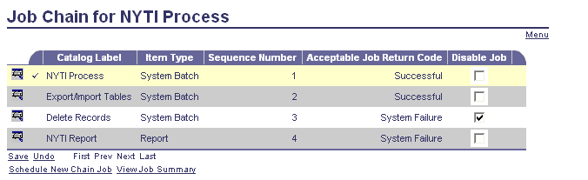

NYTI does not use custom parameters and certain job parameters must be updated prior to job run. Parameters are set on the first job in the chain at run time.
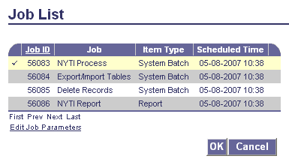

The base year being rolled from and the new-year being initialized must be entered at run time. The Run Mode parameter should be pre-populated as 1 for “Populate” and this should be double checked. Current settings will copy effective dates (at the time of writing this has a related incident for improperly populating end dates on the new records) and will copy inactive COA elements. These can be adjusted as necessary.
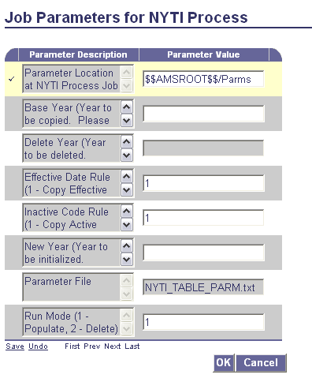

Currently BUDFCON records are not being updated by the roll. These records should be updated manually on BUDFCON by inserting the new-year records.

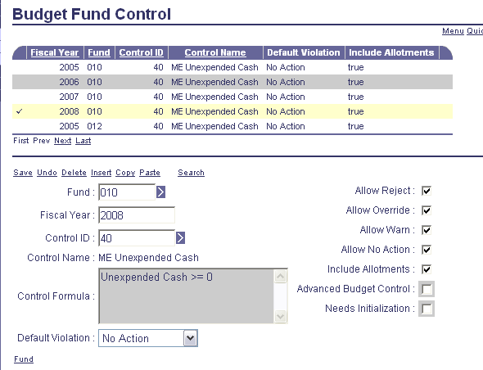

The needs initialization flag will also be set by adding these records. This sets a dirty flag indicator on the database object table gn_fund_cnst which can be deleted manually in the data base by setting the Drty_Fl indicator to 0 as long as no budget activity has occurred in the new year. Alternately the Budget batch job Calculate Budget Controls Amounts can be run.

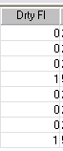

Because this program updates the organizational chart-of-account tables which are used in security, it is important to regenerate the MRT (memory resident tables) after population of new-year data. Certain budget tables are also updated that are in memory. For these security and budget tables with records inserted or deleted, a bounce of the application is required for the NYTI changes to take effect.

Budget Roll Process

The Budget Roll process automatically creates budget lines in a target year based on budget lines in a source year. Budget lines in any type of budget structure can use the Budget Roll Process, except those that do not have a Budget Fiscal Year as the key to its budget lines. Additionally, budget lines that have the multiple year value (9999) in the Budget Fiscal Year field will not be selected by the process, as they do not need to be rolled.

The Budget Roll process also contains the ability to roll certain budget features including allotments and budget level controls. Most of the parameters of the Budget Roll Process come from the Parameters for Budget Roll Process (PBRP) table. The first job step in the chain contains a batch parameter where the ID of a PBRP record is specified to pass the parameters to the job.

Maine uses two separate Budget Roll processes. The first creates zero dollar budget lines. The second rolls Unexpended Cash from all funds other than 010 and 012 to the Rollover Budget for the new-year.

The BGCA document is used for both Budget Rolls and the following changes should be made to the DCTRL record before the roll. In addition to the normal settings DCTRL should now be checked to allow Future Accounting Periods, Future Fiscal Years and Override of BFY Staging and saved as shown below. If it is desired to use a document date in the future then that field would also be checked.

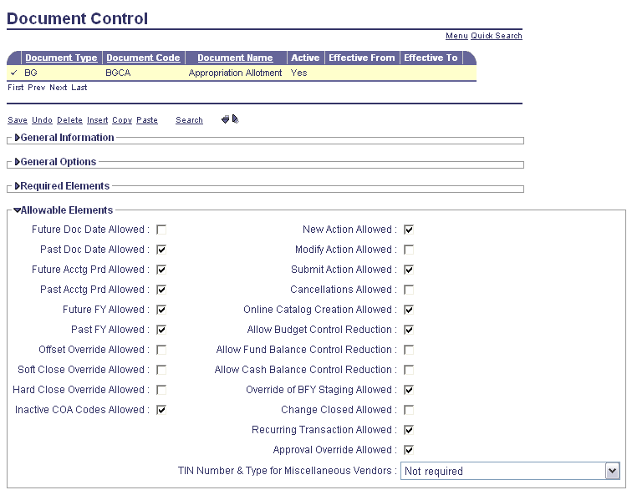

Note that the Inactive COA Codes allowed is checked but logic is not available on BGCA document to use this functionality. If budgets are needed for inactive elements such as appropriations then these should be activated in advance of the Budget Roll Process.

The budget roll process uses custom parameter tables found through the PBRP Page Code (Parameters for Budget Roll Process.) Two PBRP tables have been established in Maine for the budget rolls and will be described following for the two separate roll processes.

- Zero Dollar Budget Roll

  - The first required step for this roll is to use the BUDST (Budget Structure) Table to change the presence optional setting for Budget Structure 90 Level 3. This is necessary in order to ensure that Level 3 and its allotments are rolled. Be sure to search for Budget Structure 90 in BUDST. Then select Level 3:

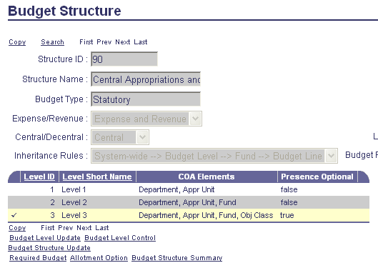

Select Budget Level Update as highlighted above and then choose Level from the Left Navigation Menu:

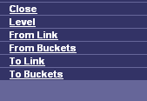

Then uncheck the Presence Optional Flag and save the record:

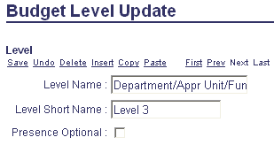
Uncheck Presence Optional

The Servers must be bounced after this change.

  - PBRP Parameter 1 is pre-set with a Roll Mode to Create Zero Dollar Lines. PBRP 1 should then be updated to ensure that the correct Source BFY and Target BFY are included and the record saved. This step is critical because the existing record requires a BFY in order to save the record and will therefore always have at least a Target BFY probably from the previous year’s roll. Also double check to ensure that the “Include Allotments” flag is checked as shown below.

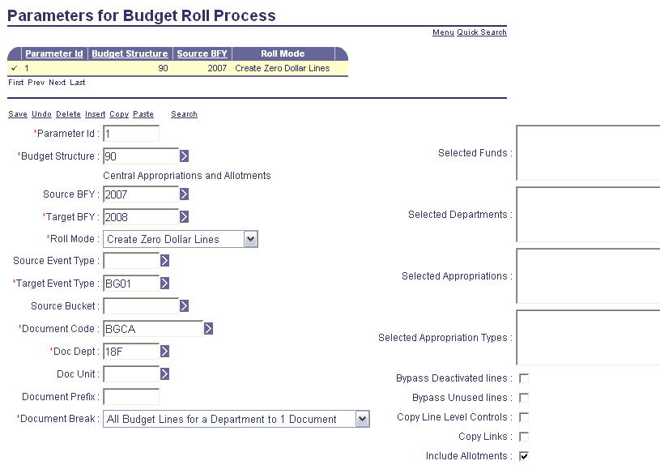

  - The Zero Dollar Budget Roll should first be run in Report Only mode using the Budget Report Job of Budget Roll:

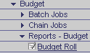

Parameter setup is as follows:

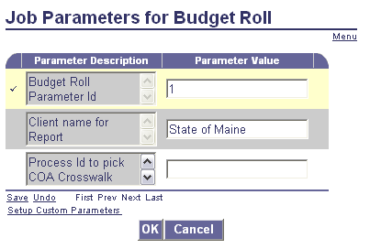

Resulting Reports will be shown as:

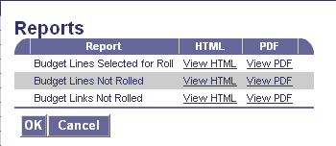

If properly completed the Budget Lines Selected for Roll report will show lines at Level 3. These will be properly rolled up during the full roll process. The lines not selected report should be null. Budget Links are not used in Maine.

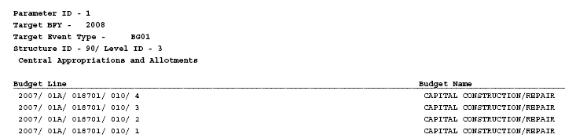

  - If parameter errors etc are identified these should be corrected and the reports run again. After clean reports are obtained, the document load section of the Budget Chain Job “Budget Roll Chain” should be setup to run. The 3rd and 4th job in the Chain should be disabled as shown and the record saved:

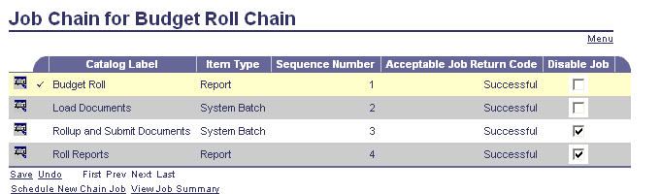

Parameter values should be set on job one of the chain as shown:

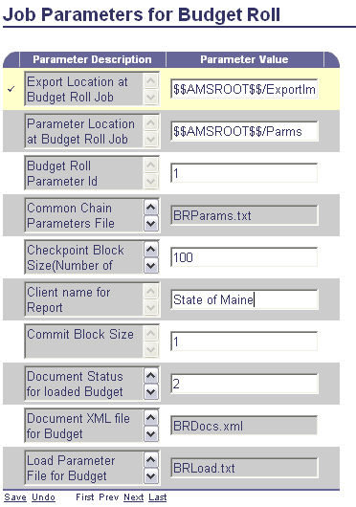

The chain can then be run. This will create and load BGCA documents at level 3 that can be reviewed prior to submission. If problems are found with the run these BGCA documents can be discarded through the use of the SysManUtil batch job discard process.

  - Once the resulting documents have been verified the a new Budget Roll Chain Job can be created and submitted by disabling the first two jobs of the chain and saving. No parameter updates are necessary before submitting this chain job.

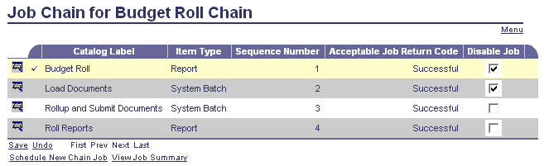

  - The resulting zero dollar budgets in the new-year can be reviewed at this time. Note that inactive budgets from the previous year have been activated by this process for the new-year.

- Unexpended Cash Budget Roll

Maine rolls Unexpended Cash from the old year budget for all funds except 010 and 012 to be the Roll Forward amount for the New Year. Unexpended Cash in the old Year is left intact. A reversion event type is used for the old budget fiscal year even though Maine does not use a Reversion Bucket currently.

Note that the Unexpended Cash bucket in Maine has been adjusted from an Expense Bucket to a Budget Bucket to allow this activity. Currently zero dollar unexpended cash balances do not roll and should be identified in advance so that BGCA documents can be manually created to load the negative amounts.

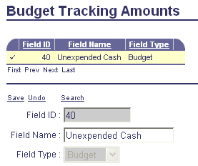

  - The first required step for this roll is to use the BUDST (Budget Structure) Table to change the presence optional setting for Budget Structure 90 Level 3 back to its original Presence Optional setting. This is necessary in order to ensure that Level 3 and its allotments are not rolled and for on-going operations. Be sure to search for Budget Structure 90 in BUDST. Then select Level 3:

Select Budget Level Update as highlighted above and then choose Level from the Left Navigation Menu:

Then check the Presence Optional Flag and save the record:

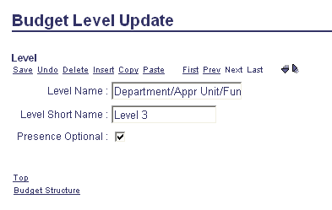
Re-check Presence Optional

The Servers must be bounced after this change.

  - PBRP (Parameters for Budget Roll Process) 2 is used for the Unexpended Cash Budget Roll and is pre-set with a Run Mode to “Roll Unused Budget.” PBRP Parameter 2 should be updated to ensure that the correct Source BFY and Target BFY are included and the record saved. The list of included funds is necessary to ensure that Funds 010 and 012 are not rolled. This should be reviewed to ensure that it includes all current Maine Funds that should be rolled. Also double check to ensure that the “Include Allotments” flag is not checked as shown below.

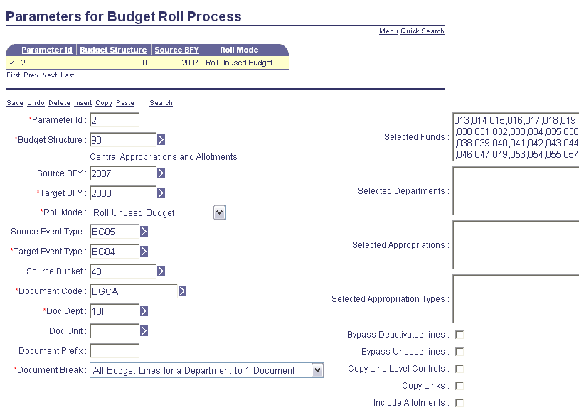

The Unexpended Cash Budget Roll should first be run in Report Only mode using the Budget Report Job of Budget Roll:

Parameter setup is as follows:

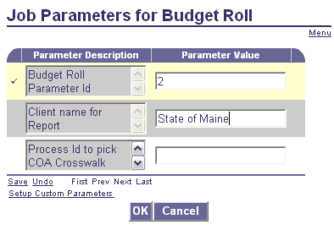

Resulting Reports will be shown as:

If properly completed the Budget Lines Selected for Roll report will show lines at Level 2. These will be properly rolled up during the full roll process. The lines not selected report should also be populated showing lines at Level 2 and can be reviewed as necessary for accuracy. Budget Links are not used in Maine.

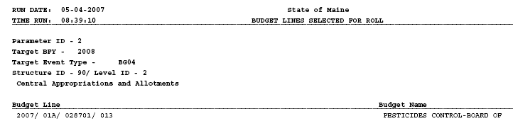

  - If parameter errors etc are identified these should be corrected and the reports run again. After clean reports are obtained, the document load section of the Budget Chain Job “Budget Roll Chain” should be setup to run. The 3rd and 4th job in the Chain should be disabled as shown and the record saved:

Parameter values should be set on job one of the chain as shown:

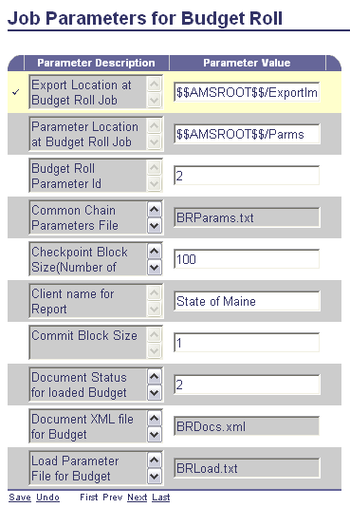

The chain can then be run. This will create and load BGCA documents at level 2 that can be reviewed prior to submission. If problems are found, these BGCA documents can be discarded through the use of a Utilities SysManUtil batch job discard process.

  - Once the resulting documents have been verified then a new Budget Roll Chain Job can be created and submitted by disabling the first two jobs of the chain and saving. No parameter updates are necessary before submitting this chain job.

  - The resulting Roll Forward budgets in the new-year can be reviewed at this time.

Contract Roll Process

Agreements with vendors frequently extend beyond the current budget fiscal year. Lines recorded against future budget years may not have an available budget. These lines will use a non-accounting event type of PR08 that will not result in any budget updates. As budgets become available during the life of the agreement, the non-accounting event type must be changed to PR05 an event type that will update and reserve appropriate budget amounts. One objective of the Contract Roll process is to change non-accounting event types used to record contract terms in future budget fiscal years to accounting event types.

The second objective of the Contract Roll is to un-reserve any accounting lines not specifically locked for a given BFY. An accounting line marked as Reserved Funding is for a future budget fiscal year and is not available to be automatically liquidated by a payment. As the new years funding becomes available, the line will be available for payment. The Contract Roll program will change the Reserved Funding indicator for an accounting line from Yes to No. Lines that have a Reserved Funding value of Locked will not be changed.

The third objective of the Contract Roll is to increment the fiscal year of out year lines. To validate chart-of-accounts, the current fiscal year is always used on both non-accounting and accounting event types in both current budget fiscal year and future budget fiscal years when the original entry is done. The Contract Roll program will increment the fiscal years of out year lines to reflect the new fiscal year. No postings will result from this change alone, as changes to the Fiscal Year and Accounting Period fields on an accounting line alone will cause any new postings.

- DCTRL must be changed temporarily on the CT documents that will be modified by this Process. Future Document Dating, Future Accounting Periods, Future FY and Override of BFY Staging should be allowed.

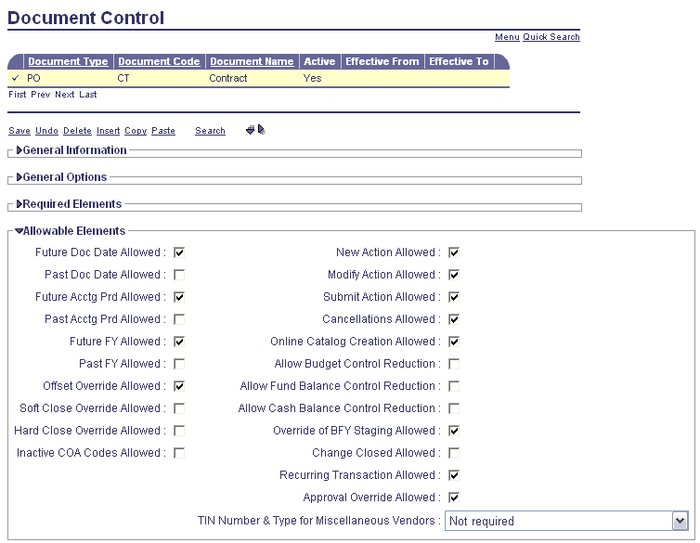

- The Contract Roll Process does not use custom parameter tables and is found in the General Accounting area of the Batch Catalog. This process does not have a report only mode. The job should be run 1st to create and load documents by disabling the last three jobs in the Chain and saving as shown:

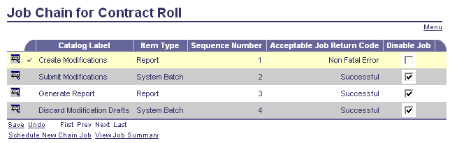

Page 1 of the Parameter values are shown below. The Accounting Period on the Modification documents should be APD 1 of the new fiscal year. Note that the selected FY should be the target FY for changing event types from PR08 to PR05. This should be the new FY rather than the old FY.

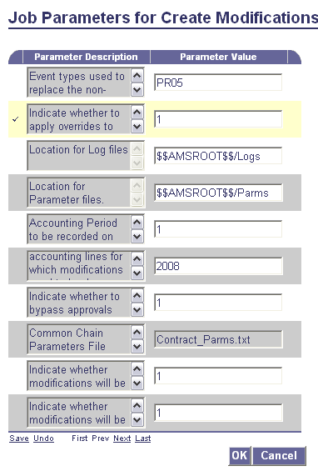

Page 2 of the Parameter values is shown below. Ensure that only CT documents are selected for the Roll. The Fiscal Year on the Modification documents should be the new fiscal year.

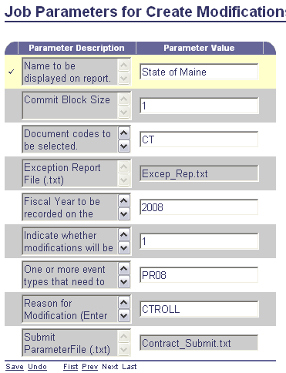

Although shown as a report item type, no report is created for this job and the resulting documents must be reviewed.

- After review the last three jobs of the chain can be scheduled and run. Jobs 1 and 4 should be disabled. Disabling job 4 ensures that reject drafts are not discarded and allows further review before deciding on a course of action. No changes to parameter values are necessary.

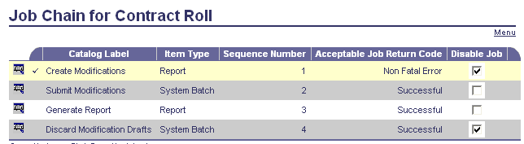

Open Activity Roll Process

When a year comes to a close, there are many documents still un-referenced with accounting activity that has not yet reached its final state. The Open Activity Roll chain job takes the activity in the old budget fiscal year forward into the next year through a series of document modifications, often referred to as 'rolling'. When activity is rolled, the program generates the necessary document modification, and then changes the existing BFY on selected accounting lines to the ‘Target Year’ BFY, which is specified in parameter setup. The chain job rolls pre-encumbrances and encumbrances, based on the activity having a Close Action of Roll on the System Options (SOPT). Further selection of activity is then based on settings on the Parameters for Roll Process (RLPA) table. Each instance of the chain is associated with a single record on that table that provides selection criteria as well as date information to be placed on the document modifications.

Maine uses two separate Open Activity Roll processes both without related budget activity. The first process rolls open pre-encumbrance activity from RQS Documents only. The second rolls open encumbrance activity from BPO, CT and DO Documents only. The appropriate RQS, BPO, CT and DO documents are modified by the process to close nominal and equity balances for the old FY and create new balances in the new FY.

- Changes should be made to the DCTRL records for RQS, BPO, CT and DO Documents before the roll. In addition to the normal settings, DCTRL should now be checked to allow Future Document Date, Future Accounting Periods, Future Fiscal Years and Override of BFY Staging and saved as shown below. If it is desired to use a document date in the future then that field would also be checked.

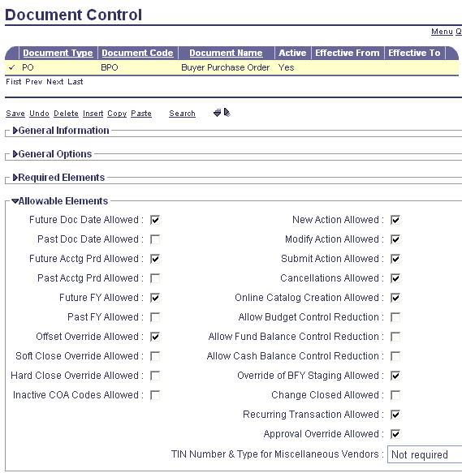

- A review should be made to the General Details section of SOPT for FY being closed at this time to ensure that Pre Enc Close Action and Enc Close Action are set for Roll to allow the Roll to take place.

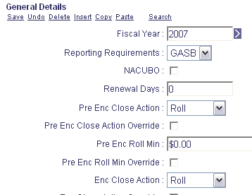

- Ensure that Period 14 is created on the APD (Accounting Page) Table and is open in the old FY for entries related to the Open Activity Rolls.

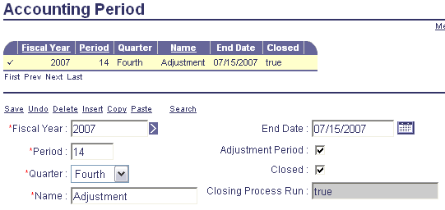

- Additionally two settings must be reviewed and updated in APPCTRL (Application Parameters) Table. The BACKOUT_APD should be pre-set to 14. The BACKOUT_FY should be changed to the FY from which the pre-encumbrances and encumbrances are being rolled.

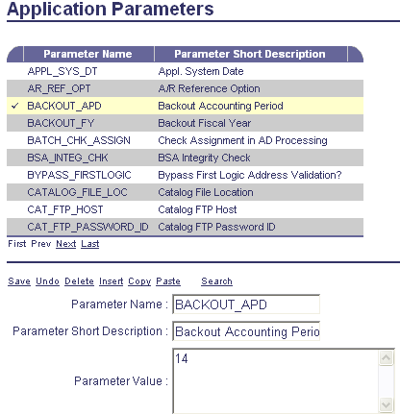

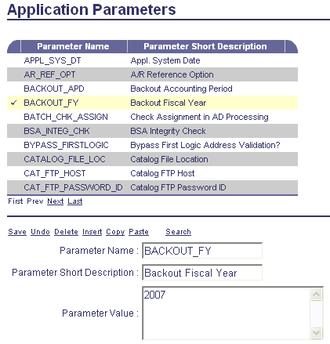

The Application Servers must be bounced after this change.

- The two open activity roll processes use six separate custom parameter tables which are reached through Page Code RLPA (Parameters for Roll Process.) All six of these must be updated for the roll processes and will be discussed in the following sections.

- Pre-Encumbrance Roll

Only open Pre-Encumbrance balances on RQS documents are rolled to the following year. Open Pre-Encumbrance and Reserve for Pre-Encumbrance balances are liquidated in the old FY and re-created in new FY through Modification Documents.

- The first step in the Pre-Encumbrance Roll Process is to run in Report Only mode. This is controlled both through the custom parameter table selected and the job selected for the roll. RLPA 1 is used for this run. Note that the run mode is “Report Only.” Ensure that only RQS documents are selected based on Event Types PR02 and PR03. The Closing BFY, Modification FY and Modification APD should be updated as needed. The Modification FY should be the new FY and Modification APD Period 1. Changes should be saved. (Note although the Param setup will be handled separately in this document for each phase of the process it is probably simpler to review and update all six of the RLPA parameter tables at the same time before beginning the process. Remember to add Record Dates for Params1 and 4 as the first day of the new FY.)

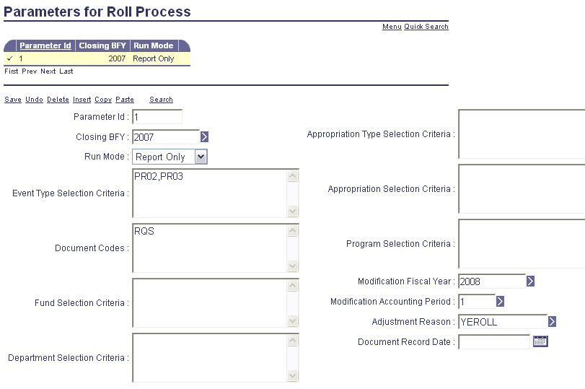

The Pre-Encumbrance Roll Process can then be run in the Report Only Mode from General Accounting Reports in the Batch Catalog:

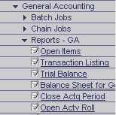

The Parameter values set at run time are as follows: It is critical that the value for the 3rd param value “Use Detail Pre-Selection Table” be set to 2 to ensure that selection is made from the Document Catalog. (1= Use Pre-Selection table as input, 2= do not use Detail Pre-Selection table but use document catalogs.)

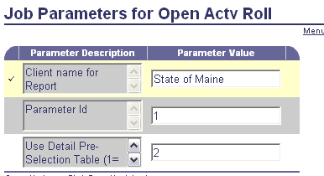

The resulting report showing Open Lines to be Rolled can then be reviewed. It is separated by Department and Document Code.

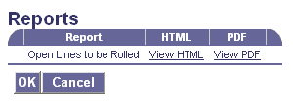
Also useful is the”Pending Exists” column which allows pending status documents to be reviewed and rejected, approved or by-passed.

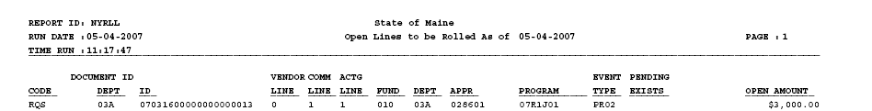

- The next step in the Pre-Encumbrance Roll Process is to run the chain in Pre-Select mode. This is controlled both through the custom parameter table selected and the job selected for the roll. RLPA 2 is used for this run. Note that the run mode is “Pre-Selection.” Ensure that only RQS documents are selected based on Event Types PR02 and PR03. The Closing BFY, Modification FY and Modification APD should be updated as needed. The Modification FY should be the new FY and Modification APD Period 1. Changes should be saved.

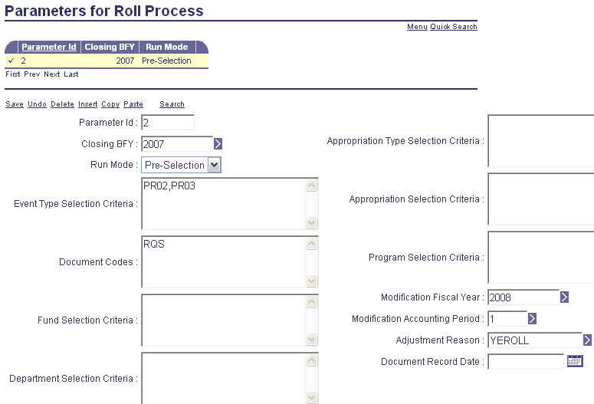

The Job can then be run from the General Accounting Chain Jobs in the Batch Catalog as “Open Actv Roll.” All but the first job in the chain are disabled for this roll and saved.

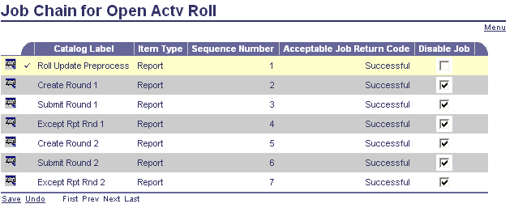

Page 1 of the Param Values for the job is shown and should not need to be changed from the batch setup default values.

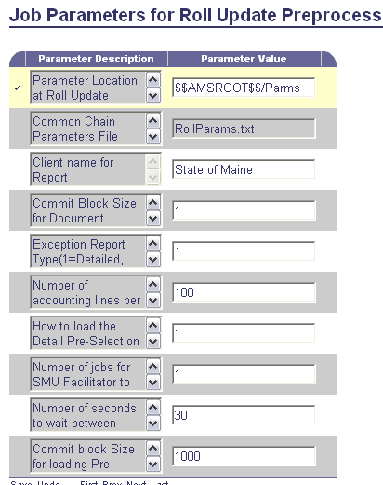

Page 2 of the Param values does need to be changed at run time to ensure that RLPA value 2 is used and that selection is made from the Document Catalog. Values are highlighted below.

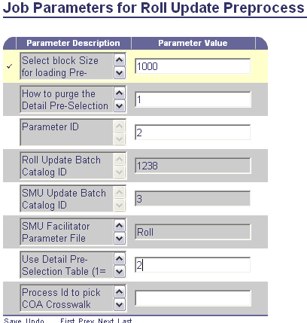

The job can then be run. This run populates the RLPSD (Roll/Lapse Detail Pre-Selection) Table. Based on the criteria used in the How to Load Detail Pre-Selection Param above (value 1), RLPSD is loaded with all values checked. The table is then manually reviewed for items that should not be rolled based on age criteria. These items are deselected as shown:

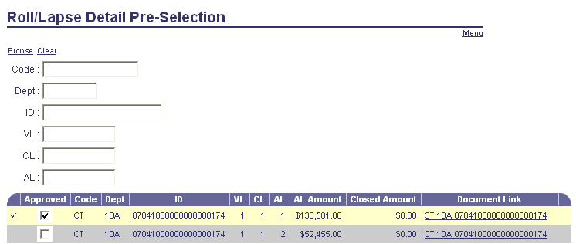

- After the pre-select process is complete on RLPSD the open activity roll process is run a final time using RLPA 3. Note that the Run Mode is “Update.” In addition to setting the closing BFY, Modification FY and APD, the record date should be set as the first day in the new FY and the record saved.

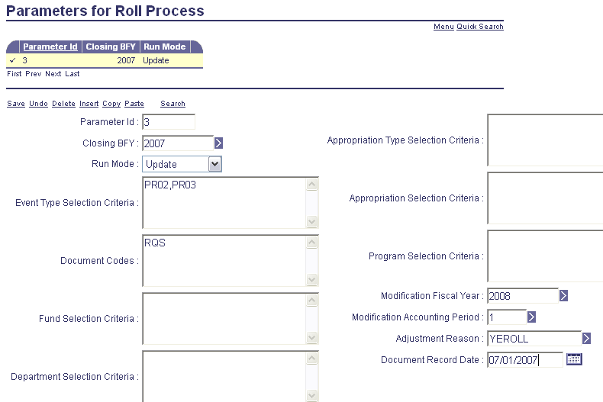

The Chain is then run from the General Accounting Chain Jobs in Batch Control with all jobs active. Note that the batch run user id must be active on the USER (Procurement User) Table.

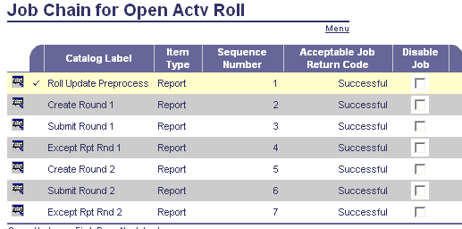

An open incident exists regarding the Create Jobs terminating after identifying specific issues on documents that could not be created. To date this has happened with Procurement Users that are no longer active on the Procurement Table and with Documents that have been forced closed without finalizing values. Documents up to this point are created. Workaround is to pre-identify items through SQL and deselect on RLPSD. Users can be temporarily added back to the USER table. All documents created up to the point of the failure should be discarded through SysManUtil and then the entire Open Activity Chain re-run.

- The Document Catalog should be reviewed after chain completion to ensure that no modification documents have been left in draft status or have been rejected.

- Encumbrance Roll

Only open Encumbrance balances on BPO, CT and DO documents are rolled to the following year. Open Encumbrance and Reserve for Encumbrance balances are liquidated in the old FY and re-created in new FY through Modification Documents.

- The first step in the Encumbrance Roll Process is to run in Report Only mode. This is controlled both through the custom parameter table selected and the job selected for the roll. RLPA 4 is used for this run. Note that the run mode is “Report Only.” Ensure that only BPO, CT and DO documents are selected based on Event Types PR05 and PR06. The Closing BFY, Modification FY and Modification APD should be updated as needed. The Modification FY should be the new FY and Modification APD Period 1. Changes should be saved

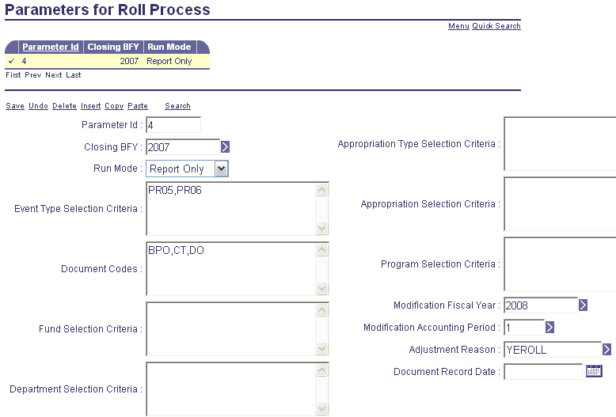

The Encumbrance Roll Process can then be run in the Report Only Mode from General Accounting Reports in the Batch Catalog:

The parameter values set at run time are as follows: It is critical that the value for the 3rd param value “Use Detail Pre-Selection Table” be set to 2 to ensure that selection is made from the Document Catalog. (1= Use Pre-Selection table as input, 2= do not use Detail Pre-Selection table but use document catalogs.).

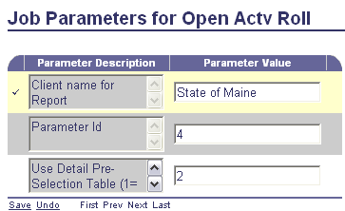

The resulting report showing Open Lines to be Rolled can then be reviewed. It is separated by Department and Document Code.

Also useful is the “Pending Exists” column which allows pending status documents to be reviewed and rejected, approved or by-passed.

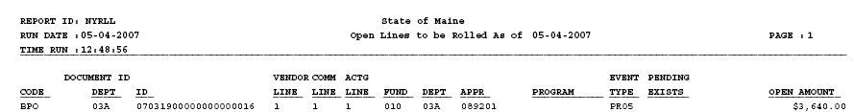

- The next step in the Encumbrance Roll Process is to run in Pre-Select mode. This is controlled both through the custom parameter table selected and the job selected for the roll. RLPA 5 is used for this run. Note that the run mode is “Pre-Selection.” Ensure that only BPO, CT and DO documents are selected based on Event Types PR05 and PR06. The Closing BFY, Modification FY and Modification APD should be updated as needed. The Modification FY should be the new FY and Modification APD Period 1. Changes should be saved.

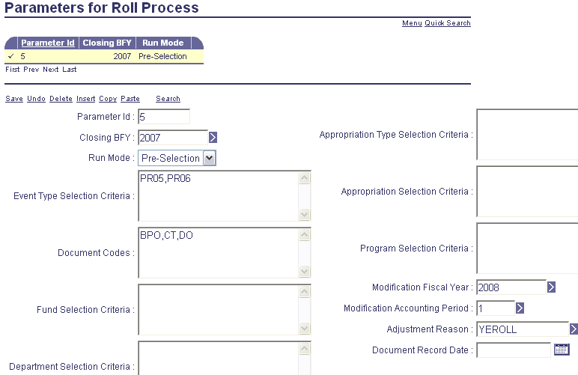

The Job can then be run from the General Accounting Chain Jobs in the Batch Catalog as “Open Actv Roll.” All but the first job in the chain are disabled for this roll and saved.

Page 1 of the Param Values for the job is shown and should not need to be changed from the batch setup default values.

Page 2 of the Param values does need to be changed at run time to ensure that RLPA value 5 is used and that selection is made from the Document Catalog. Values are highlighted below.

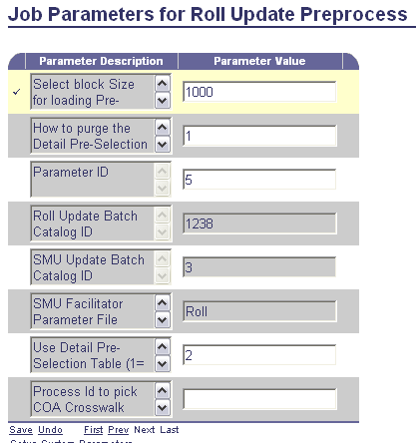

The job can then be run. This run populates the RLPSD (Roll/Lapse Detail Pre-Selection) Table. Based on the criteria used in the How to Load Detail Pre-Selection Param above (value 1), RLPSD is loaded with all values checked. The table is then manually reviewed for items that should not be rolled based on age criteria. These items are deselected as shown:

- After the pre-select process is complete on RLPSD the open activity roll process is run a final time using RLPA 6. Note that the Run Mode is “Update.” In addition to setting the closing BFY, Modification FY and APD, the record date should be set as the first day in the new FY and the record saved.

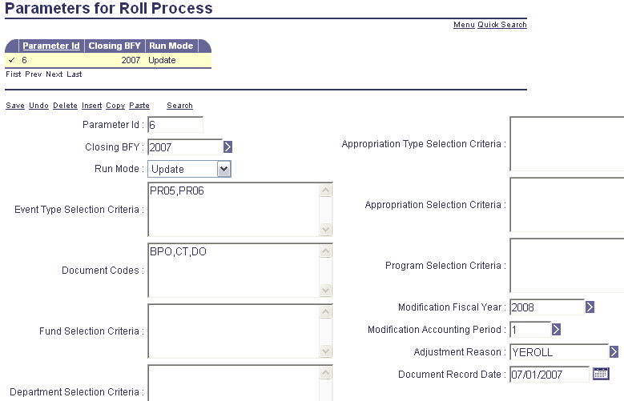

The Chain is then run from the General Accounting Chain Jobs in Batch Control with all jobs active. Note that the batch run user id must be active on the USER table.

An open incident exists regarding the Create Jobs terminating after identifying specific issues on documents that could not be created. To date this has happened with Procurement Users that are no longer active on the Procurement Table and with Documents that have been forced closed without finalizing values. Documents up to this point are created. Workaround is to pre-identify items through SQL and deselect on RLPSD. Users can be temporarily added back to the USER table. All documents created up to the point of the failure should be discarded through SysManUtil and then the entire Open Activity Chain re-run.

- The Document Catalog should be reviewed after chain completion to ensure that no modification documents have been left in draft status or have been rejected.

Open Activity Lapse Process

All open Pre-Encumbrance and Encumbrance balances that are not rolled during the Open Activity Roll Process described above are lapsed in the old year. This includes GAP and GAE documents that are not eligible for the Roll Process. Open Pre-Encumbrance, Encumbrance and Reserve for Pre-Encumbrance and Reserve for Encumbrance balances are liquidated in the old FY through Modification Documents.

- Modifications must be made to the General Details section of SOPT at this time to allow the remaining items to be lapsed. Pre Enc Close Action and Enc Close Action are set for Roll to allow the Roll to take place. These setting now need to be changed to Lapse to allow lapsing of the remaining documents.

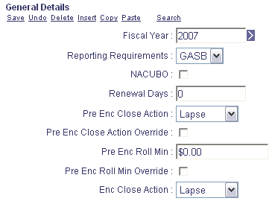

- DCTRL settings on the ABDL and CBDL Lapse Documents should also be adjusted as necessary. Vendor must be optional and BFY Staging must be overridable. The Time Restriction Severity must also be overrideable and / or have no Time Restriction set. The examples below are for the ABDL. CBDL settings must be the same.

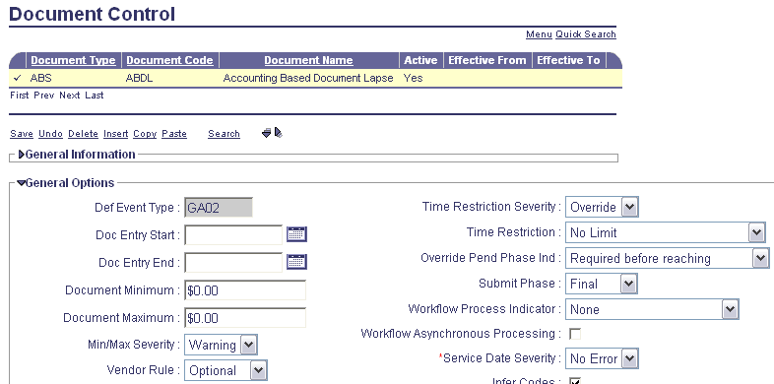
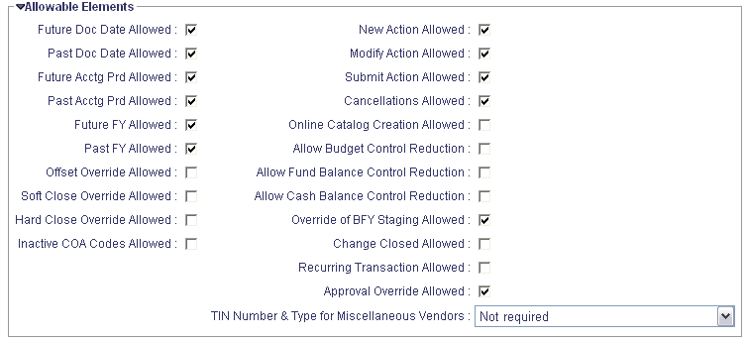

- The PROGREQ (Unit / Program Requirement) Table must be temporally set to have any listed records set for Program optional.

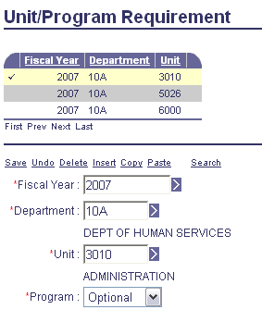

- The first step in the Open Activity Lapse Process is to run the chain in Report Only mode. This is controlled both through the custom parameter table selected and the job selected for the roll. The Open Activity Lapse Process uses three custom parameter tables found through Page Code LPPA (Parameters for Lapse Process.) LPPA 1 is used for this run. Note that the run mode is Report Only. The Closing BFY should be updated as needed. The Fiscal Year should be the FY being lapsed and the accounting period always 14. The Document Record Date should be set as the last day of the Fiscal Year being Lapsed. (Although each LPPA setting is separately described it is probably simpler to complete all three at this time.)

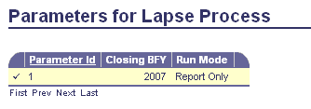

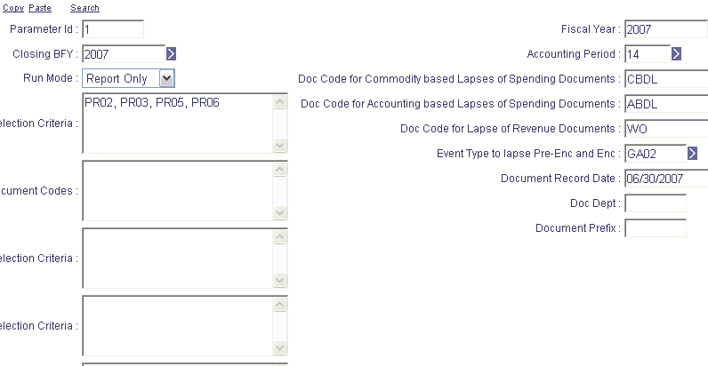

The Open Activity Lapse Process can then be run in the Report Only Mode from General Accounting Reports in the Batch Catalog:

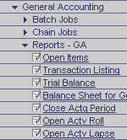

Parameter values set at run time are as follows: It is critical that the value for the 3rd param value “Use Detail Pre-Selection Table” be set to 2 to ensure that selection is made from the Document Catalog. (1= Use Pre-Selection table as input, 2= do not use Detail Pre-Selection table but use document catalogs.)

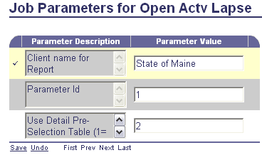

The resulting report showing Open Lines to be Rolled can then be reviewed. It is separated by Department and Document Code.



Also useful is the “Pending Exists” column which allows pending status documents to be reviewed and rejected, approved or by-passed.

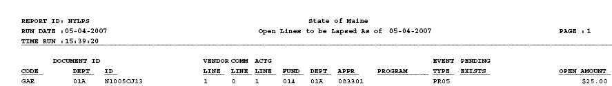

- The next step in the Open Activity Lapse Process is to run in Pre-Select mode. This is controlled both through the custom parameter table selected and the job selected for the roll. LPPA 2 is used for this run. Note that the run mode is “Pre-Select.” The Closing BFY should be updated as needed. The Fiscal Year should be the FY being lapsed and the accounting period always 14. The Document Record Date should be set as the last day of the Fiscal Year being lapsed.

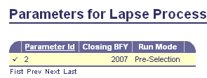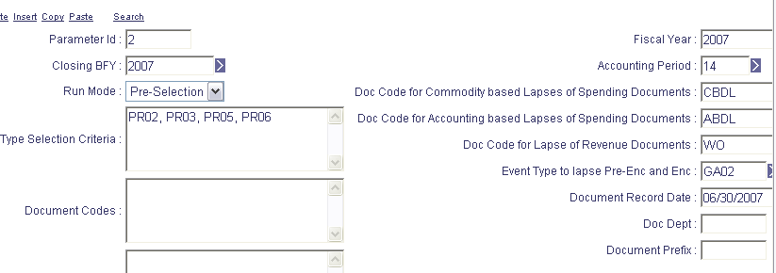

The Job can then be run from the General Accounting Chain Jobs in the Batch Catalog as “Open Actv Lapse.” All but the first job in the chain are disabled for this roll and saved.

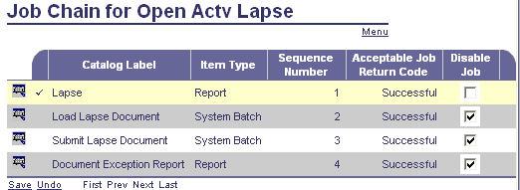

Page 1 of the Param Values for the job is shown and should not need to be changed from the batch setup default values.

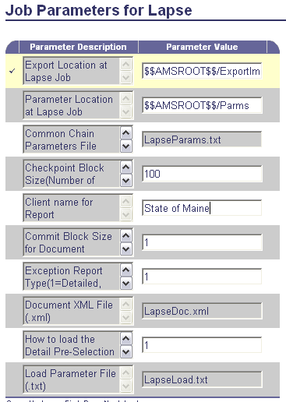

Page 2 of the Param values does need to be changed at run time to ensure that LPPA value 2 is used and that selection is made from the Document Catalog. Values are highlighted below.

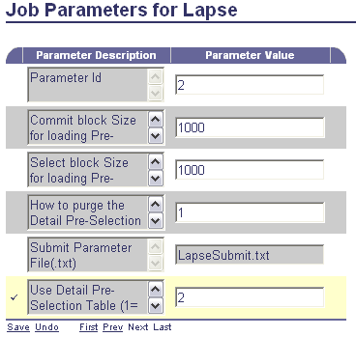

The job can then be run. This run populates the RLPSD (Roll/Lapse Detail Pre-Selection) Table. Based on the criteria used in the How to Load Detail Pre-Selection Param above (value 1), RLPSD is loaded with all values checked. The table is then manually reviewed for items that should not be rolled based on age criteria. These items are deselected as shown:

- After the pre-select process is complete on RLPSD, the open activity roll process is run a final time using LPPA 3. Note that the Run Mode is “Update.” The Closing BFY should be updated as needed. The Fiscal Year should be the FY being lapsed and the accounting period always 14. The Document Record Date should be set as the last day of the Fiscal Year being lapsed.

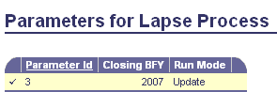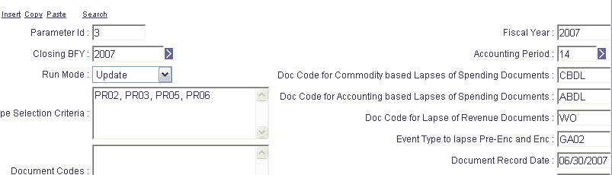

The Chain is then run from the General Accounting Chain Jobs in Batch Control with the first two jobs active. This will load but not submit the lapse documents for review and correction as necessary. These draft documents could be discarded with SysManUtil if necessary. Note that the batch run user id must be active on the USER table.

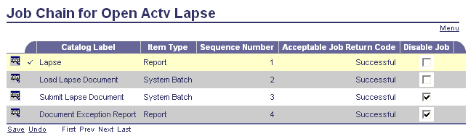

Parameter values are set on the first job in the Chain as follows. No changes should be necessary to Page 1

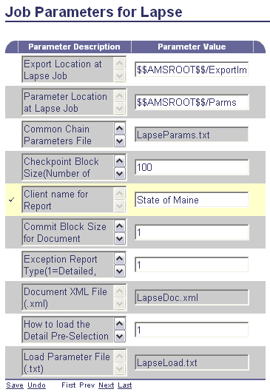

Page 2 of the Param values does need to be changed at run time to ensure that LPPA value 3 is used and that selection is made from the Pre-Selection table. Values are highlighted below.

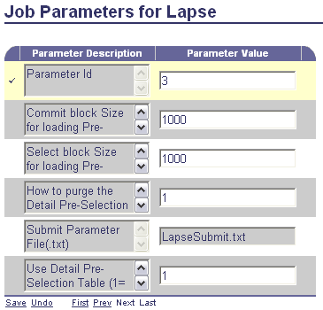

- After review of the loaded Lapse Documents the last two jobs of the Chain can be run. Disable the first two jobs and save. No change of Param setup is needed at run time.

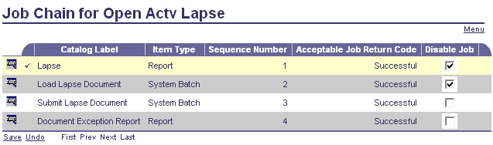

Annual Close Process

The Annual Close Process should be completed as early as possible in the new FY. The purpose of the process is to facilitate the movement of nominal and real account balances from an accounting fiscal year that is being closed to the subsequent accounting fiscal year. The nominal account balances (e.g., cash expenditures, accrued expenditures, collected revenue and billed revenue) are closed to fund balance, retained earning or agency due to as specified for the associated fund. These closings into equity accounts are offset by two ‘dummy’ accounts, which summarize all nominal spending and nominal revenue account activity. Such a balance is necessary to keep the original nominal activity in the ledgers.

Real account balances are rolled forward from the accounting fiscal year that is being closed to the subsequent accounting fiscal year. These account balances roll to the new accounting fiscal year using the level of detail found on the input ledger into annual close. If more than fund, sub fund and balance sheet details are required for real account reporting, then the input ledger should summarize real accounts down to that level of detail. Closing entries into the old year, use the same chart of accounts (COA) as recorded in that closed year, but use a generic closing posting code so that real account activity will remain in the ledgers. New year activity is recorded using the posting code originally used in the closed year. Analysis should be done to balance the level of detail needed in a close and the time required to execute a close because the input ledger contains a large volume of records, resulting from a high level of chart-of-account detail

Certain accounts used as offsets in the normal course of business are closed into a special equity account known as Net Assets. Such accounts are offsets for debt, pre-paid assets, and fixed asset expenditures. This new equity account contains many of the accounts that make up the difference between modified and full accrual accounting. If modified accounting reports are being created, then the Net Assets account is not included. However, for full accrual accounting, a fund’s Net Assets account is combined with fund balance or retained earnings accounts to arrive at a complete picture of equity.

To accommodate the movement of account balances, two annual closing related fiscal periods have been created. Period 99 has been created for the accounting fiscal year that is being closed. Additionally, period 0 has been created for the subsequent accounting fiscal year into which account balances are being rolled. These fiscal periods have been reserved for the annual closing activity only to allow for the segregation of annual close transaction activity. It is the Allowed Accounting Periods for Document Code (AAPDC) table controls what document codes can hit what periods based on a time restriction of accounting period for the document code on the Document Control (DCTRL) table.

The Annual Closing Process facilitates the movement of account balances though the creation of one or more Journal Voucher Annual Close (JVAC) documents. The process creates a minimum of two JVAC documents for each unique combination of fund code and sub fund code, one for the closed year and one for the new year. Document header descriptions on these documents specify the fund, sub fund and the year for easy identification. More than two documents will be created for a combination when the Number Of Accounting Lines control on the System Options – General Tab is exceeded. In such a case, a line is generated automatically with the Balance Posting Code. On the final document for that combination and year, another balancing line is generated that offsets the first.

- Annual Close Pre-Run Setup.

- All standard, weekly, monthly, and annual batch jobs such as Bad Debt Write-Off and Fixed Asset Depreciation should be completed prior to beginning the annual close process.

- SPEC should be reviewed to ensure that BSA’s are included for Retained Earnings, Fund Balance, Master Closing Object, Master Closing Revenue Source and the Annual Close Offset.

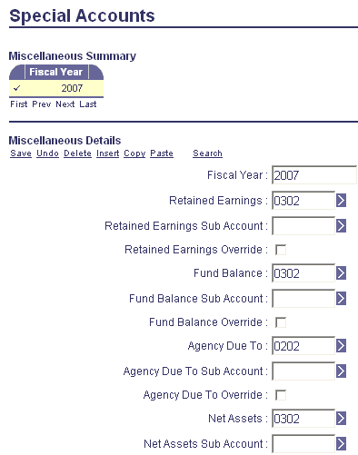
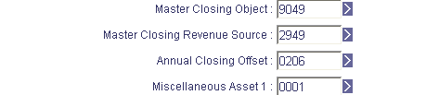

- Ensure that all FY’s and APD’s prior to the period being closed are shown in hard closed status.

- Run the Close Actg (Accounting) Period Batch Job from General Accounting Reports in the Batch Catalog.

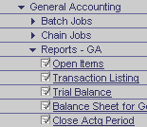

Set Job Parameters to close all accounting periods other than 99 in the year being closed. Period 14 should be the last period before 99. The 3rd Param value set as 1 will close period 14 and all prior periods in the listed FY.

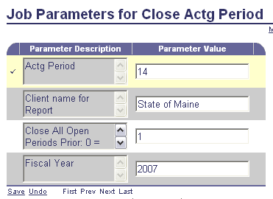

- Using a Data Base tool review Pstng_Ln_Cat. If any items with a Doc_Phase_Cd of 3 (Final) or 5 (Historical Final) have a Jrnl_Pstng_Ind of 1 (Not Ready to Post) are noted then the Journal Posting Initiator job should be run for the Document Codes involved. This is an Accounts Payable job.

- The Journal Engine should then be run from the Posting Batch Jobs menu in the Batch Catalog. No run time parameter setup is required.

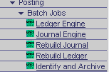

- The Ledger Engine should then be run from the Posting Batch Jobs menu in the Batch Catalog. No run time parameter setup is required. Multiple iterations can be run simultaneously.

- Using a Database tool search Jrnl_Log for failed work. These items would have a St_Fl indicator of 1, 4, or 9. If found the Ledger Engine should be run in the re-process failed work mode.

- Using a database tool review Doc_Hdr for Pending Documents. These would have a Doc_Phase_Cd of 2. These should all be rejected or completed prior to closing the FY.

- Review ADNT (Auto Document Numbering Table) to ensure that the JVAC Document is active with the Prefix ACLS for the Source and Target Fiscal Years.

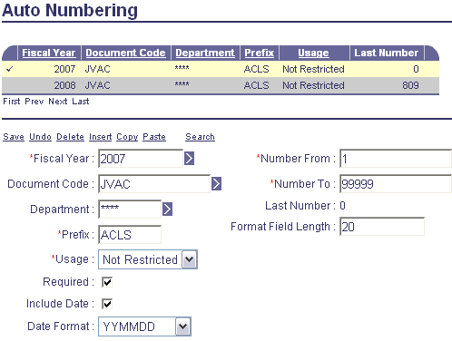

- Run Systems Assurance 3 from the Systems Assurance Batch Jobs menu in the Batch Catalog. No run time changes are necessary to the Job Parameters.

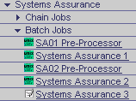

No out of sync conditions should be found. If there are out of sync conditions corrective action should be taken before running the Annual Close Process Chain.

- Annual Close Chain

- The Annual Close Chain job is found in the General Accounting Chain Job menu of the Batch Catalog.

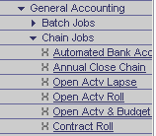

- The first run should be completed by disabling and saving the last three jobs in the chain in order to create the temp_fydad database table which can be reviewed with a database tool in order to analyze all JVAC lines that will be created by the close process.

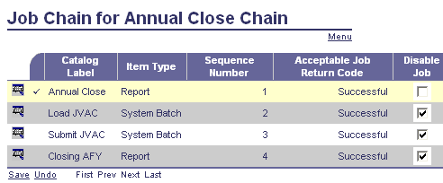

Parameter setup is shown following. The FY to be closed must be entered on the first page of the parameter setup.

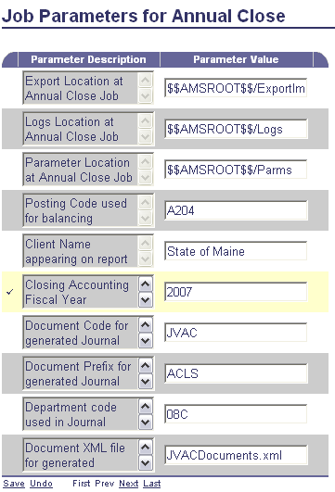

Page 2 requires entry of the FY to be opened and a Report Only value of 1 as shown and highlighted.

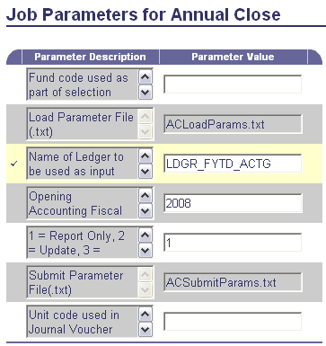

- After review of the temp_fydad table and the decision to proceed the chain then can be run for the first two jobs only in order to Load but not submit the JVAC documents.

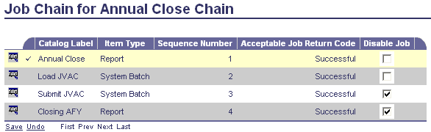

The fifth parameter on the second parameter page should be changed from the 1 used above to a 2 for Update.

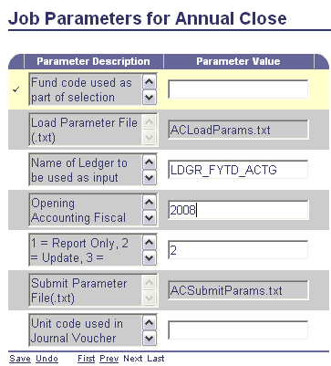

JVAC’s will be loaded in Held Status. These can be reviewed as needed. Note that closing year JVAC’s are loaded first followed by opening year JVAC’s. These can be discarded with SysManUtil if required and the job re-run as needed.

- After the decision to proceed, the last two jobs in the chain can be run together to submit the documents and generate an exception report.

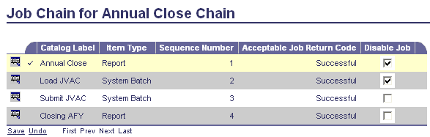

Parameter values for the opening and closing FY are required on the Closing FY Report Job.

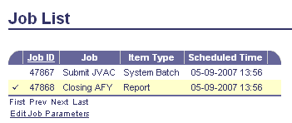

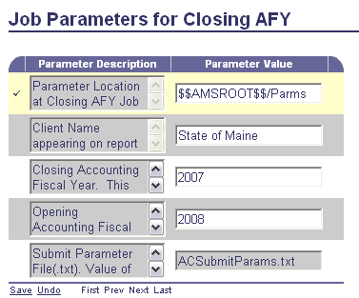

- The FY table can then be reviewed to ensure that the FY year being closed is shown as hard closed. The soft close flag should also be checked at that time.

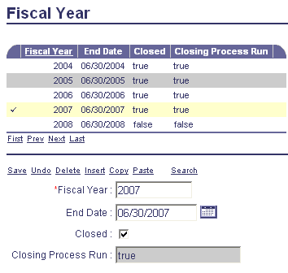
Check Closed Box

- The APD Table should be checked to ensure that period 99 of the FY being closed and period 0 of the new-year now show the Closing Process has been run. The soft closed box should also be checked and saved at this time.

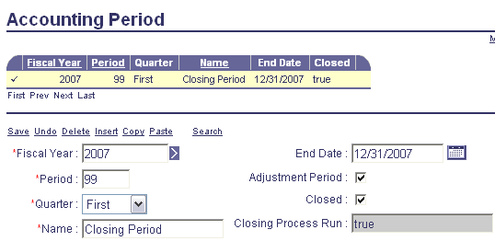
Check Closed Box

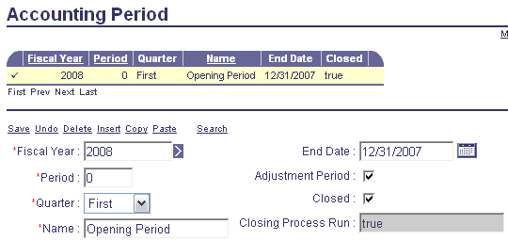
Check Closed Box

